SELECT TOP

The SELECT TOP clause statement in SQL is used to specify the number of rows (or percentage of rows) to return from a query. It is primarily used to retrieve a limited number of records from a result set.
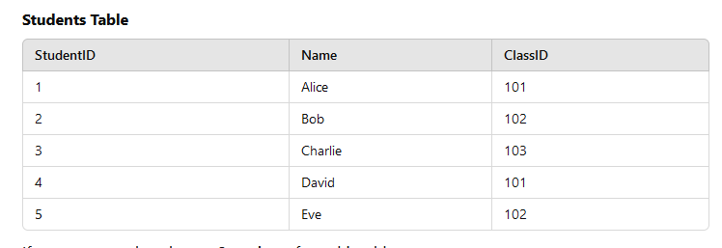
If you want to select the top 3 students from this table:
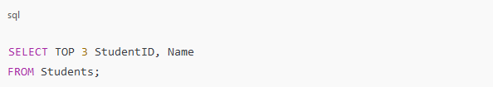
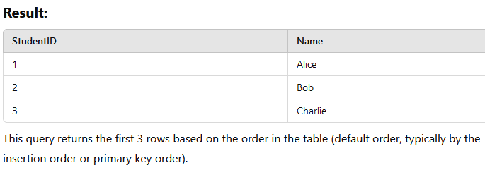

SELECT TOP – ORDER By
To get the top 3 students with the highest StudentID, use the ORDER BY clause:
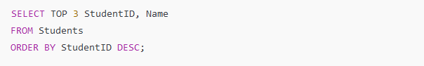
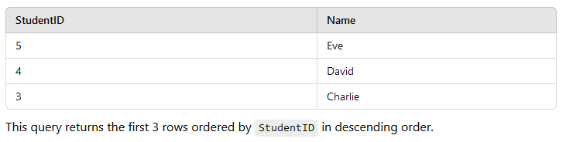
SELECT TOP – PERCENTAGE
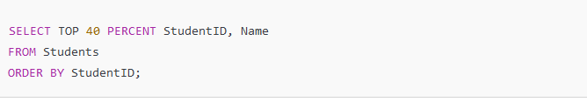
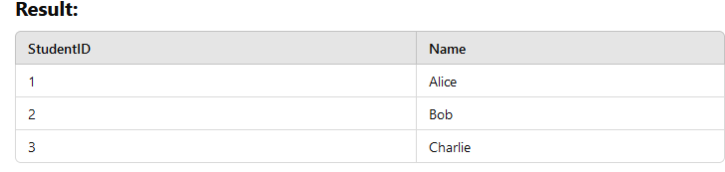
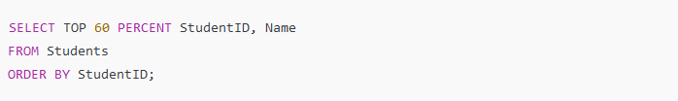
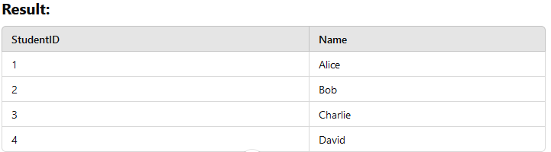
Now, 60% of 5 is 3 (rounded up), so the top 4 students are returned
Rounding: The percentage is typically rounded up in SQL Server, so it might return more rows than the exact percentage.

Aggregate function
Aggregate functions in SQL are special functions that perform calculations on multiple rows of data and return a single summarized value. These functions are commonly used in data analysis to compute totals, averages, counts, or other summaries from a dataset.

Common Characteristics of Aggregate Functions:
- Operate on Multiple Rows: Aggregate functions process a set of values from a column.
- Return a Single Result: They summarize the data into one value, such as a sum, count, or average.
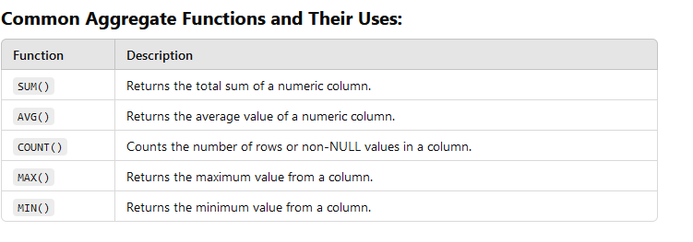
Sum()
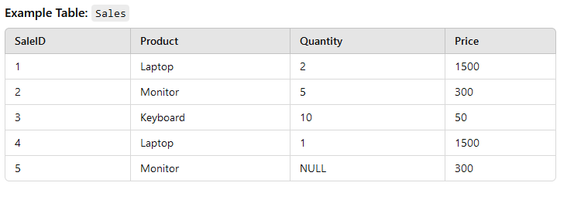
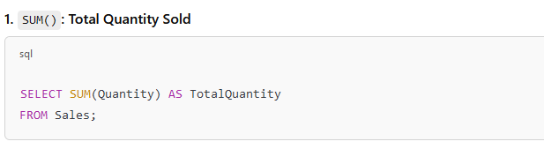
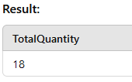
Avg()
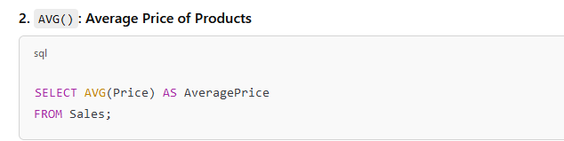
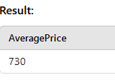
Count()
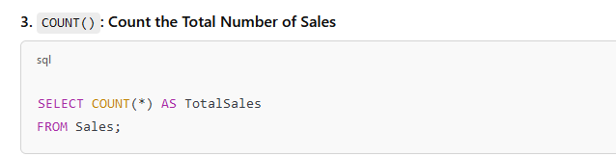
Use COUNT(*) to count all rows.
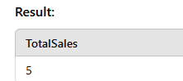
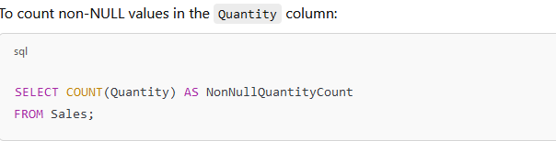
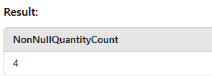
Max()
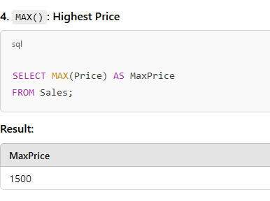
Min()
